RENY CREATIVE STUDIO
Professional photography is more than simply taking pictures—it's about telling stories, capturing emotions, preserving milestones, and creating lasting visual legacies that can be enjoyed for generations. Whether you're a growing family wanting to document special memories, a professional seeking polished corporate headshots, an engaged couple celebrating a new chapter, or a business owner showcasing products and services, investing in professional photography is an investment in memories that never lose value.
At Reny creative studio, we specialize in creating stunning, high-quality imagery tailored to every client's unique vision and needs. From family portraits and maternity photography to corporate headshots, branding sessions, engagement photography, and product photography, our mission is to transform important moments into timeless works of art.
Located conveniently in Nakuru, our studio combines technical expertise, creativity, and a client-centered approach to deliver an exceptional photography experience from start to finish. Every session is thoughtfully planned to ensure you feel comfortable, confident, and excited throughout the process.

Why Professional Photography Matters

Professional photography offers something different: intentional, carefully crafted images designed to stand the test of time.
When you invest in a professional photography session, you're gaining access to:
Superior Image Quality

Professional cameras, lenses, lighting equipment, and editing techniques produce images with exceptional clarity, color accuracy, and detail.

Expert Guidance
Many people feel nervous in front of a camera. Professional photographers understand how to direct poses, create natural expressions, and capture authentic moments that look effortless.
Customized Sessions
Every individual, family, couple, and business has unique goals. A professional session is tailored specifically to your vision and desired outcome.
Lasting Value
Professional portraits become treasured keepsakes, family heirlooms, marketing assets, and personal branding tools that continue providing value for years.
Stress-Free Experience

Rather than worrying about camera settings, lighting, angles, or editing, you can focus entirely on enjoying the experience while professionals handle the technical details.

The Studio Experience at Reny creatives studio
One of the biggest advantages of choosing Reny creative studio is the complete studio experience we provide. Our goal is to make every client feel welcome, comfortable, and confident from the moment they walk through our doors.
We understand that photography can feel intimidating, especially if you've never participated in a professional photoshoot before. That's why we've designed every aspect of our studio and workflow to ensure a seamless and enjoyable experience.
A Comfortable, Climate-Controlled Environment


Our climate-controlled studio provides the perfect environment for photography year-round. Whether it's a hot summer day or a rainy afternoon, you'll enjoy a comfortable atmosphere that allows you to focus entirely on your session.
This controlled environment also ensures consistent lighting conditions, helping us create beautiful images regardless of outdoor weather conditions.
Professional Lighting Equipment
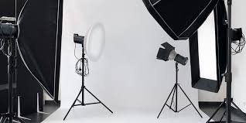
Lighting is one of the most important factors in photography.
At Reny creative studio, we utilize professional-grade lighting equipment to create flattering, high-quality portraits that highlight your best features. Our advanced lighting systems allow us to achieve a variety of styles, from bright and modern corporate headshots to dramatic artistic portraits.
Professional lighting helps eliminate harsh shadows, enhances skin tones, and ensures every image meets the highest quality standards.
Relaxing Client Lounge
Our welcoming client lounge offers a comfortable space where you can prepare for your session, review ideas, or simply unwind before stepping in front of the camera. Family members and guests can also relax comfortably while waiting.
Photography Services Available at Reny creatives
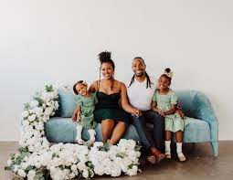
Family Portrait Photography
Our family sessions focus on creating genuine interactions, natural smiles, and timeless images that celebrate your family's unique story.
Whether you're updating annual family photos or commemorating a special milestone, we create portraits you'll treasure for generations.
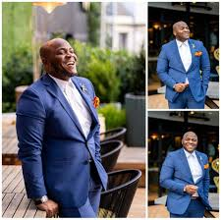
Corporate Headshots and Personal Branding

High-quality headshots help professionals make strong first impressions on LinkedIn profiles, company websites, business cards, and marketing materials.
We create polished, approachable images that communicate professionalism, confidence, and authenticity.
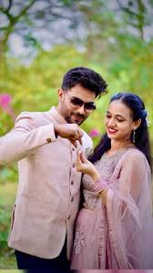
Engagement Photography

Our engagement sessions are designed to celebrate your relationship through beautiful, authentic photography that reflects your personalities and connection.
These images can also be used for wedding invitations, save-the-date cards, wedding websites, and social media announcements.

Baby shower Photography
Our expectancy sessions celebrate this remarkable journey with elegant, meaningful portraits that capture the anticipation and beauty of motherhood.

Product Photography
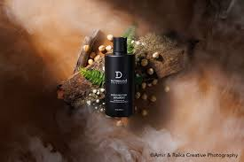
Businesses need professional imagery to compete effectively online.
Our product photography services help brands showcase products with clarity, consistency, and visual appeal that drives customer engagement and sales.
How to Prepare for Your Session: Top 3 Tips
Preparation can make a significant difference in the success of your photography session. Here are our top recommendations for achieving the best possible results.
1. Choose Your Wardrobe Carefully
Your clothing plays a major role in the final appearance of your photographs.
Consider these wardrobe tips:
- Choose outfits that fit well and make you feel confident.
- Stick to timeless styles rather than trendy patterns.
- Avoid clothing with large logos or distracting graphics.
- Select colors that complement your skin tone.
- Iron clothing beforehand to eliminate wrinkles.
2. Coordinate Outfits Without Matching Exactly
Instead of everyone wearing the same color, choose complementary shades that work together harmoniously.
Examples include:
- Navy, cream, and beige
- Earth tones
- Soft pastels
- Neutral color palettes
This approach adds visual interest while maintaining a cohesive appearance across the final images.
3. Bring Meaningful Props
Consider bringing items that reflect your story, such as:
- Family heirlooms
- Children's favorite books or toys
- Sports equipment
- Musical instruments
- Business tools
- Engagement-related accessories
- Ultrasound images for maternity sessions
What Happens After Your Session?
Our editing process ensures every final image reflects the high standards that define Reny creatives.
After editing is complete, you'll receive access to your gallery where you can review, select, download, and share your favorite images.
Why Clients in Nakuru Choose Reny creatives
Clients choose Reny creatives because we combine technical expertise, artistic creativity, and exceptional customer service.
Our commitment includes:
- Personalized attention
- Professional equipment
- Comfortable studio environment
- High-quality editing
- Flexible session options
- Consistent results
- Friendly, experienced photographers
Invest in Memories That Last a Lifetime
Long after trends change, technology evolves, and years pass, photographs remain one of the most valuable ways to revisit life's most meaningful moments.
Whether you're documenting family milestones, elevating your professional image, celebrating an engagement, welcoming a new child, or showcasing your products, professional photography preserves memories and opportunities that deserve to be captured beautifully.
At Reny creatives, we're honored to help individuals, families, couples, and businesses throughout Nakuru create images they'll cherish for years to come.
View Our Portfolio
Book Your Session
Contact Us
0741459599
renylesh9@gmail.com

